NUBBLE!
Virtual Image Publishing Limited

Single user licence £15 + VAT
Multiple user licences available including enhanced licences which allow home use by teachers and pupils. See website for further details of possibilities and a free downloadable demonstration version
http://www.virtualimage.co.uk

One approach to arithmetic is that ‘in order to practise walking you start learning to run’; in other words you change the focus of the activity. The advantages of this lie deep in the way children naturally learn. Sometimes you find a piece of software that adopts this approach and that you can heartily recommend. Nubble! is one such.

Nubble! started life as a board game and was originally called Number Quest. Virtual Image has worked with the inventors of the board game to produce a high quality interactive version.

The object of the game is to lay a path made of hexagons from bottom left to top right (1 to 100), gaining as many points as possible in the process. The interactive version of Nubble! may be played with 1, 2, 3 or 4 players. One player can play solo or against the computer, timed or untimed. The difficulty can be adjusted to easy, middling or hard.

There is a ‘cheat chart’ which you can use to help with multiplication sums when you are stuck and this enables children with a wide range of calculating experience and speed to take part.
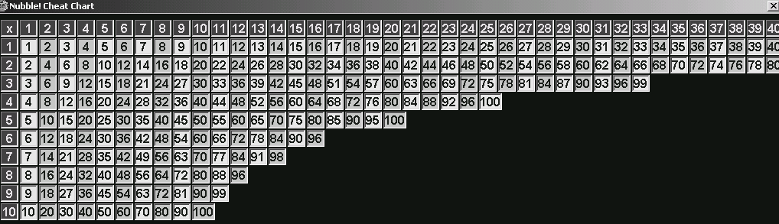

As you would hope from a game which develops arithmetic skills and strategy, the scoring is complex, but accessible. You score a Nubble! when you complete a triangle of three adjacent hexagons, and this results in one hundred extra points. You score a double Nubble! when you complete the triangle with a prime number included – prime numbers are written in silver hexagons. A Double Nubble! scores two hundred extra points.

Olivia is 8. Her preferred strategy is to play against the computer with the timer on because she can go for the lower numbers and get more Nubble!s and double Nubble!s ‘because they are more obvious’. She says ‘It is always possible to get the lower numbers except 19 and 41. These are difficult ones. Sometimes you make silly mistakes – if you do you lose your turn. ‘

Alastair (age 11) found some of the colours made it difficult to read the numbers inside them. He says ‘This is not so important here because the numbers are in order but software developers should think about these things.’

Both children think that Nubble! is worth more than £15 because it is fun and they believe it improves their mathematics. They compare it favourably with their favourite software game ‘The Mathematical Journey of the Zoombinis’.

The children have played on Nubble! a lot. For them, it is a different way of doing maths from the ways they have seen before. They have not noticed how many calculations they have done while playing and that is what I meant about changing the focus.

Sue, Olivia and Alastair Johnston-Wilder

